For Immediate Release

Contact:  Mike Ruzicka

414.778.4929 or 414.870.1874

[mike@gmar.](mailto:mike@gmar.)com

**February 13, 2025**

# January Home Sales Up 7.1%

|  |  |
| --- | --- |
| Highlights |  |
| * Sales Up 7.1% in January, Good Start to 2025 |
| * Listings Up 10.9% |
| * Average Sale Price Up 14% |

|  |  |  |  |
| --- | --- | --- | --- |
| **January Sales** | | | |
| County | 2024 | 2025 | % Change |
| Milwaukee | 535 | 533 | -0.4% |
| Waukesha | 200 | 229 | 14.5% |
| Ozaukee | 49 | 66 | 34.7% |
| Washington | 64 | 80 | 25.0% |
| Metro Area | 848 | 908 | 7.1% |
|  | | | |
| Racine | 112 | 131 | 17.0% |
| Kenosha | 105 | 89 | -15.2% |
| Walworth | 69 | 69 | 0.0% |
| SE WI Area | 1,134 | 1,197 | 5.6% |
|  | | | |
| **January Listings** | | | |
| County | 2024 | 2025 | % Change |
| Milwaukee | 777 | 827 | 6.4% |
| Waukesha | 275 | 326 | 18.5% |
| Ozaukee | 67 | 100 | 49.3% |
| Washington | 115 | 116 | 0.9% |
| Metro Area | 1,234 | 1,369 | 10.9% |
|  | | | |
| Racine | 157 | 192 | 22.3% |
| Kenosha | 126 | 124 | -1.6% |
| Walworth | 119 | 136 | 14.3% |
| SE WI Area | 1,636 | 1,821 | 11.3% |

Market Summary

Home sales in the Metropolitan Milwaukee market rose solidly in January by 7.1%, with 908 sales. While not in the one thousand sales range the market saw from 2018 to 2022, nine hundred sales, in January, is a great way to start the year.

Another point of optimism is the number of new listings we saw in January. Listings were up 10.9% compared to a year earlier.

We have to temper our enthusiasm, however, because sales and listings aren’t up enough to meet demand. 2023 and 2024 were miserable years, so 2025 has almost nowhere to go but up.

The market seems to be adapting to the increase in interest rates we saw two and a half years ago, resulting in fewer homeowners listing their homes. When rates went up in 2022 sellers pulled back for fear of paying higher interest rates on a new home. That resulted in fewer homes for buyers to choose from and a lot of frustration.

Listings have increased in eight of the last thirteen months, but – again – that is coming off the worst period of listings the market has seen this century. So, we really have to wait and see what the next several months bring.

In addition to homeowners not listing their homes, new construction has been a drag on the supply of housing.

Through the end of 2024 there were 2,151 permits for new construction in the four county area. Well below the roughly 4,000 new homes and condos the market needs annually.

Apart from the lack of adequate new construction and listings, demand for homes continues to remain strong. Millennial and Gen Z buyers account for 41% of the buyer market, and given their age and general income level affordability is imperative.

Any economics class will stress that when there is high demand for a product and low supply, the cost goes up. And due to the current levels of demand and supply, the average home sale price in the four-county area went up 14.0% in January, from $328,1261 in 2024 to $373,911 this past January.

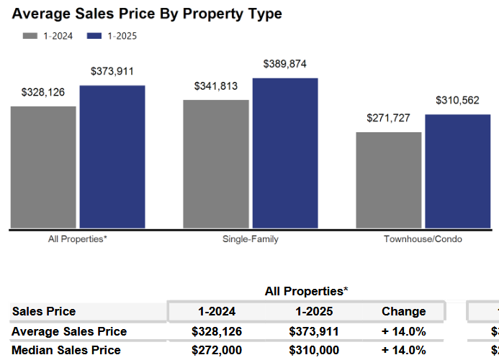That demand is being created by buyers who want all of the quality of life benefits that homeownership offers, so they are stretching to qualify for a loan, or come up with enough cash to get a house.

The supply of inventory on hand was only enough to satisfy 2.3 months of buyer demand in January.

Subtracting units with an offer that level drops to 1.0 months, significantly below the balanced market theory of 6 months.

As we have been highlighting for several years – REALTORS® have had an exceedingly challenging time helping home buyers find ownership opportunities in the form of condos and single-family houses. This results in thousands of would-be homeowners forced to stay in rental units, unable to save for a down payment and foregoing the opportunity to build wealth through a home’s equity.

Where to go

Buyers should seek the counsel of a REALTOR® in determining their best housing options, and sellers need the expert advice of a REALTOR® in making correct marketing decisions for their home.

The Greater Milwaukee Association of REALTORS® is a 5,500-member strong professional organization dedicated to providing information, services, and products to help REALTORS® help their clients buy and sell real estate. Data for this report was collected by Metro MLS, Inc., a wholly owned subsidiary of GMAR.

* Sales and Listing figures differ between the “Monthly Stats” and quarter or year-end numbers, because the collection of Monthly Stats ends on the 10th of each month, whereas quarters are a continuous tally to 12/31. For example, if a sale occurred on the 29th of the month, but an agent does not record the sale until the 5th of the next month, that sale would not be included in the sales figures of the reported month (or any subsequent month’s total) but would be added to the quarterly and annual total sales figures.

** All references to the “metropolitan” area denotes the four counties of Milwaukee, Waukesha, Ozaukee, and Washington Counties. The “region” or “Southeast Wisconsin” refers to the four metropolitan counties (Milwaukee, Waukesha, Ozaukee, and Washington), plus Racine, Kenosha, and Walworth Counties, to the south.

Seasonally adjusted **i**nventory tells us how many months it would take to sell the existing homes on the market. The seasonally adjusted inventory level for January was 2.3 months. Subtracting **1,027 “active offer”** listings from those available for sale (about 80% of listings with an offer sell) yields **2,475** listings, which equals 1.0 months of inventory.

With 3,227 current listings providing 2.3 months of inventory, the market would need an additional 5,175 units to push inventory to six months. Six months of inventory is considered a “balanced” market. If inventory falls below six months, the market favors sellers, and when inventory exceeds six months, it is a buyer’s market.